Video 21 — Human-in-the-Loop (HITL) using LangGraph
CampusX Agentic AI using LangGraph · Playlist position 21 · Theory-first study notes
Watch the lesson · Full playlist
Study scope: Important conceptual material and small teaching examples, not a recreation of the tutorial project. These are original explanatory notes based on the video’s public chapter outline and the linked technical sources—not a transcript.
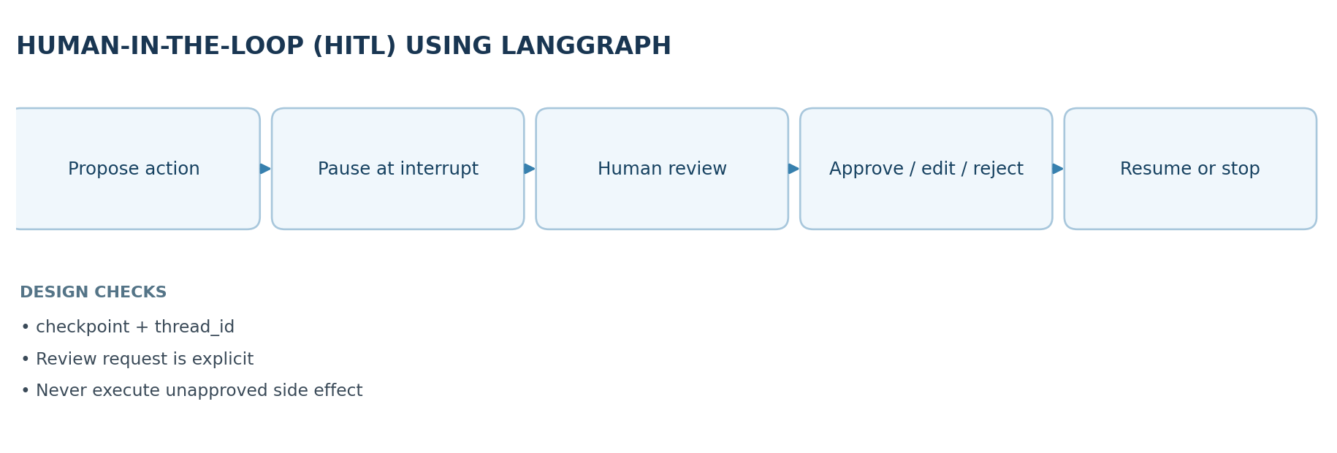

Learning objectives
By the end of this lesson, you should be able to explain when an autonomous agent should stop and ask a person, distinguish approval from clarification and output review, and describe how LangGraph's interrupt(), a checkpointer, a thread_id, and Command(resume=...) cooperate.

1. Why human-in-the-loop matters
An agent can plan, retrieve information and invoke tools, but fluency is not proof that an action is correct or authorized. A mistaken answer is sometimes recoverable; a mistaken payment, deletion, or external message may not be. HITL creates explicit handoff points where the system pauses and a human decides whether or how execution should continue.
Two motivations are worth keeping distinct:
- Reliability: a human may correct missing facts, ambiguity, uncertain classifications or poor drafts.
- Accountability and control: a human remains responsible for sensitive actions, policy exceptions and irreversible side effects. A correct-looking model output still requires authorization if the action is high impact.
HITL does not mean a person approves every generated token. Over-review slows the workflow and produces approval fatigue; place gates where consequences, uncertainty or legal requirements justify them.

2. Four practical HITL patterns
Pattern | Trigger | Human provides | Example
Action approval | Before a side-effecting tool runs | Approve / deny / sometimes edit | Release an invoice or send an email
Output review | Before draft is published | Corrections or replacement text | Review a customer-facing response
Clarification | User request lacks a needed fact | A missing value or choice | Which account should be charged?
Escalation | System cannot safely decide | Human resolution | Disputed refund or compliance exception
Example: an agent drafts a refund of $500. Rather than executing the payment immediately, it produces a structured approval request containing the amount, payee, reason, and risk. The reviewer approves or rejects it; only an approved path reaches the actual payment tool.

3. LangGraph's pause-and-resume lifecycle
LangGraph's dynamic interrupt() pauses the graph inside a node and returns a serializable request to the caller. A checkpointer saves state. The caller retains a stable thread ID identifying the interrupted run, collects input from a reviewer, then resumes with Command(resume=value) using the same thread ID. The resumed value becomes the return value of the paused interrupt() call.
A crucial nuance: when resumed, the node executes again from its beginning. Code before the interrupt can run again. Do not put a charge, send, delete, or non-idempotent operation before an interrupt; put the approval first, then perform the side effect exactly once using an idempotency key where possible.

Minimal teaching example
from typing_extensions import TypedDict
from langgraph.graph import StateGraph, START, END
from langgraph.checkpoint.memory import InMemorySaver
from langgraph.types import interrupt, Command
class State(TypedDict):
request: str
approved: bool
def get_approval(state: State):
decision = interrupt({"question": "Approve this action?", "request": state["request"]})
return {"approved": bool(decision)}
builder = StateGraph(State)
builder.add_node("approval", get_approval)
builder.add_edge(START, "approval")
builder.add_edge("approval", END)
app = builder.compile(checkpointer=InMemorySaver())
config = {"configurable": {"thread_id": "demo-approval-001"}}
paused = app.invoke({"request": "Publish draft", "approved": False}, config=config)
# Show the interrupt request to a reviewer; collect the answer.
result = app.invoke(Command(resume=True), config=config)
assert result["approved"] is True
This illustrates pausing and resuming only; it does not actually publish anything. InMemorySaver is convenient for demonstration, but a production system needs persistent checkpoint storage and authentication for the approving reviewer.

4. Static checkpoints vs. dynamic interrupts
- Static breakpoints (interrupt_before / interrupt_after when supported) are useful during debugging and inspection at node boundaries.
- Dynamic interrupts (interrupt() inside a node) can carry a question and be conditioned on state: e.g., request approval only if amount > policy_limit.
- Tool-level approvals intercept sensitive tool calls; the agent can still autonomously perform low-risk read-only calls.
A human approval event should be logged with reviewer identity, timestamp, exact proposed action, decision, and resulting execution. This is an application design recommendation, not something automatically supplied by the graph.

5. Robust design checklist
- Specify the review boundary: which action will happen only after the human approves?
- Make requests comprehensible: pass a minimal, structured, non-secret summary to the reviewer.
- Persist across restarts: use a durable checkpointer; keep the same thread_id for resume.
- Treat resume values as untrusted input: validate allowed decisions and edited fields.
- Prevent replayed side effects: remember that the paused node restarts, and use idempotent operations.
- Handle denial and timeouts: explicitly route to cancellation, revision or escalation.
- Test both branches: approval and rejection should be correct and auditable.

6. Key distinctions and misconceptions
Approval is not evaluation. A judge-model score is not the same as human authorization. Persistence is not memory personalization. Checkpointing saves execution state for continuation; it is not automatically a store of reusable user preferences. Paused is not finished. An interrupt leaves the graph incomplete until a valid resume input arrives.

7. Quick revision
- HITL trades a small amount of autonomy for safer decisions and human accountability.
- Use interrupt() + a checkpointer + stable thread_id to pause; Command(resume=...) to continue.
- The node is re-executed from its beginning when it resumes: keep side effects after the approval gate.
- Prefer risk-based gates over blanket approval for every step.

Self-check questions
- Why is an approval gate more important for a payment tool than for a read-only search tool?
- Which three components are needed for a resumable LangGraph interrupt?
- What dangerous behavior can occur if a network request runs before interrupt()?
- How would your graph represent a reviewer rejecting a proposed action?
Suggested answers: (1) payments create side effects; (2) interrupt, checkpointer, thread ID (plus resume command to continue); (3) the request may be repeated; (4) route to a cancel/revise branch without executing the action.

Visual recap
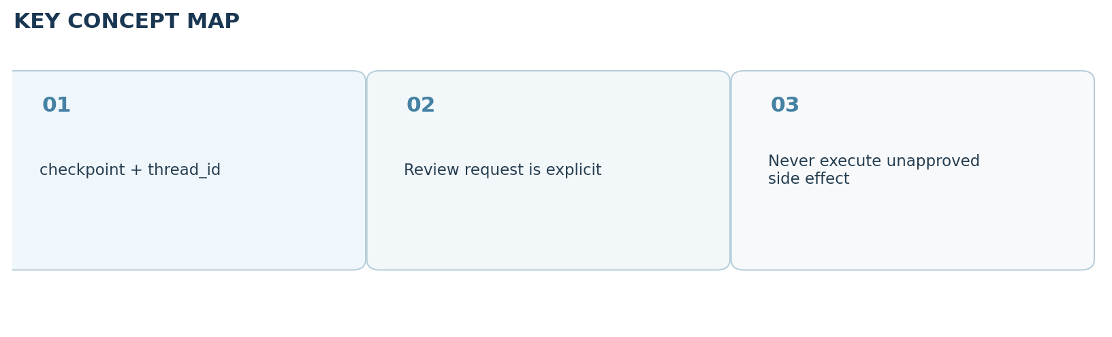

Clickable video chapters
- 00:00:00 — Introduction: What is Human-in-the-Loop?
- 00:01:14 — Why agents need human oversight
- 00:03:44 — Real-world HITL examples
- 00:04:22 — Accuracy and accountability
- 00:08:46 — Benefits of HITL
- 00:11:36 — Common HITL patterns
- 00:14:21 — LangGraph perspective
- 00:16:30 — Interrupt workflow
- 00:22:49 — Basic HITL code
- 00:31:22 — Tool-using chatbot example
- 00:39:42 — Key takeaways

References and further reading
- CampusX video and chapter list
- Official LangGraph interrupts guide
Prepared October 2026. Figures are original study diagrams, not screenshots or official CampusX illustrations. Some APIs may change; consult the linked official references before production use.

